Department of Social Welfare
Problem Statement:

Department of Social welfare receives records from different private hospitals across the country on a weekly basis. The records contain information about below poverty line (BPL) category patients. Moreover, hospitals send consolidated details of expenses incurred for these patients on monthly basis.

Flow Diagram

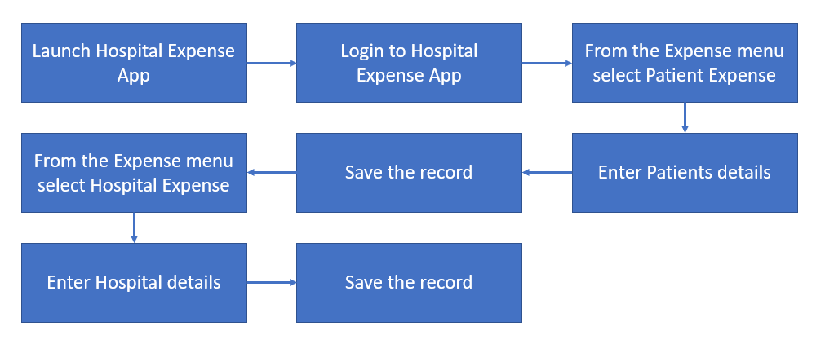

The information has following attributes
- The first report is in MS Excel format and referred as Patients’ Record.
- The second report is also in MS Excel format and referred as Monthly Expense Report
- These reports are processed one by one manually.
- The processing involves entering information from Patients Records and Monthly expenses report information into department’s windows based information management system (Refer appendix point # 1).
- Both the reports have fixed formats however the excel file (Refer appendix point # 2) might contain some invalid data. For example, some character string in age filed etc. Bot should handle it and should not allow to enter wrong data
- Department’s information management system crashes sometimes due to heavy load or database connectivity issues so the bot should account for this failure.
- Department employees calculate eligibility of grant / reimbursement before entering the expense data into the system. The calculation is done by a separate process for few positive/negative scenarios. You may generate a random value for this grant to create the solution.
Expectation:
Create a bot for automating this process using Automation Anywhere automation tool. Process the information from the reports and enter the same into Information Management System.
Coding Practices
Note: All RPA coding best practices should be followed and adhered.
- Use wait/delay commands between screen change (wherever applicable). Arbitrary waits should be strictly avoided, unless it is justified.
- The solution by default should have robust exception handling mechanism. There should be checks for consecutive system exceptions wherever applicable.
- The solution when submitted should be free of any errors.

Appendix:
- Information Management System is a window’s based application which and can be accessed using below given credentials.
Username: admin
Password: admin
- Sample Patient Report Excel file

- Sample Monthly Expense Report
Your solution will be judged on, but not limited to the following categories:
- Effectiveness (how well your solution is designed),
- Innovation (what additional features or steps you considered)
- Understands the problem in context of the technology/domain area (not Just Skill)
- Apply best/emerging practices to the solution in context of the technology/domains
- Understands implications across performance/Scalability/Security/Maintainability etc.
- Understands Design patterns/Coding standards etc.
- Provides accurate, robust and comprehensive solution for the given problem statement

